*Heaven’s Light is Our Guide*

**Rajshahi University of Engineering & Technology**

Department of Electrical & Computer Engineering

Course No: ECE 4124

Course Title: Digital Signal Processing Sessional

Experiment No: 02

|  |  |
| --- | --- |
| **Submitted by:**  Name: Md. Zayed Al Masud  Roll: 1810016  Date of Experiment: 03. 05. 2023  Date of Submission: 08. 05. 2023 | **Submitted to:**  Hafsa Binte Kibria  Lecturer,  Dept. of ECE |

**2.1 Experiment Name: Implementation of Circular Convolution**

**2.1.2 Theory:**

Convolution is a mathematical way of combining two signals to form a third signal. It is an important technique in Digital Signal Processing. Convolution is a formal mathematical operation, just as multiplication, addition, and integration. Addition takes two numbers and produces a third number, while convolution takes two signals and produces a third signal.

**Circular convolution**, also known as cyclic convolution, is a special case of periodic convolution, which is the convolution of two periodic functions that have the same period.

Generally, there are two methods, which are adopted to perform circular convolution and they are:

1. Concentric circle method
2. Matrix multiplication method

**2.1.3 Code:**

xn = [1 2 3 4];

hn = [1 1 1 1];

n1 = length(xn);

n2 = length(hn);

n = max(n1,n2);

if(n1>n2)

hn = [hn, zeros(1,n-n2)];

else

xn = [xn, zeros(1,n-n1)];

end

y = zeros(1,n);

for i=0:n-1

for j=0:n-1

z = mod(i-j,n);

y(i+1) = y(i+1)+xn(j+1).*hn(z+1);

end

end

disp(y)

subplot(3,1,1); stem(xn); xlabel('n');

ylabel('x[n]'); title('First Signal');

subplot(3,1,2); stem(hn); xlabel('n');

ylabel('h[n]'); title('Second Signal');

subplot(3,1,3); stem(y); xlabel('n');

ylabel('Y[n]'); title('Convoluted Signal');

**2.1.4 Output:**

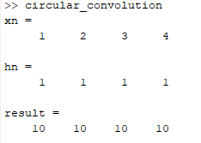

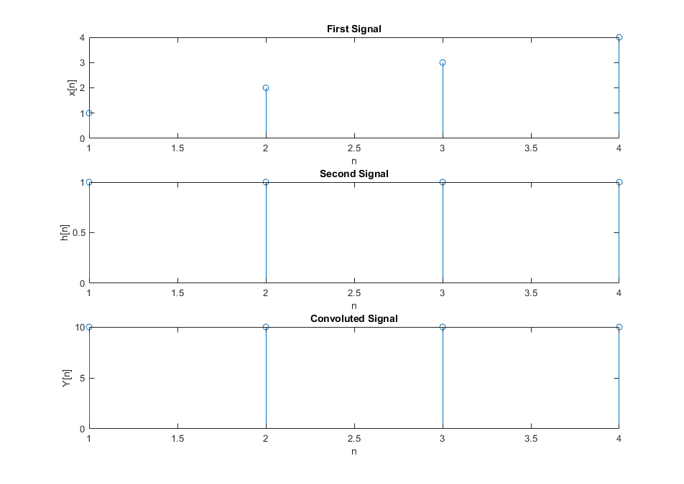

Fig 2.1: Convolution of Two Signals

**2.2 Experiment Name: Addition & Subtraction of two signals**

**2.2.1 Code:**

sig1= [0 0 0 0 0 0 1 1 1 1 1 1 0 0 0 0 0 0 0];

sig2= [0 0 0 0 0 0 0 0 0 1 1 1 1 1 1 0 0 0 0];

t = 1:19;

subplot(4,1,1);

stem(t,sig1);

xlabel('n');

ylabel('X(n)');

title('Signal 1');

subplot(4,1,2);

stem(t,sig2);

xlabel('n');

ylabel('X(n)');

title('Signal 2');

sig3 = sig1+sig2;

subplot(4,1,3);

stem(t,sig3);

xlabel('n');

ylabel('X(n)');

title('Addition');

sig4 = sig1-sig2;

subplot(4,1,4);

stem(t,sig4);

xlabel('n');

ylabel('X(n)');

title('Subtraction');

**2.2.2 Output:**

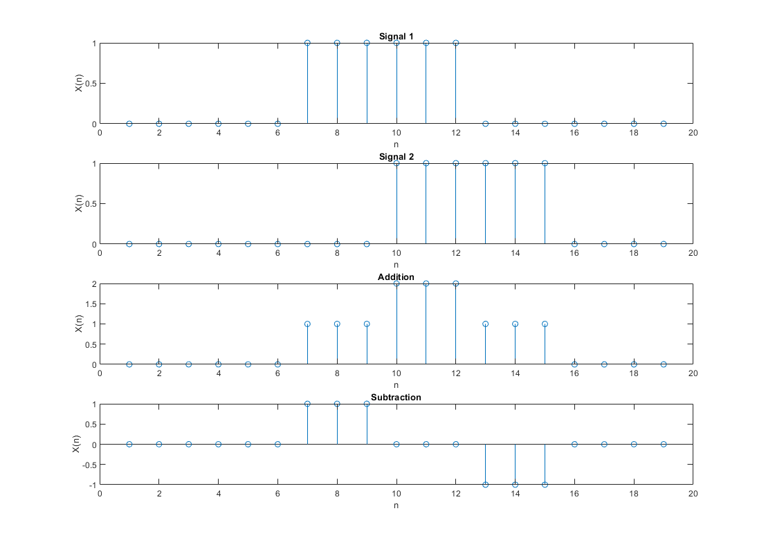

Fig 2.2: Addition and Subtraction of Two Signals

**2.3 Experiment Name: Presentation of two Signal**

**2.3.1 Code:**

t = 0:4;

t1 = 0:7;

u1 = [0 1 1 1 0];

u2 = [0 1 1 2 2 1 1 0];

subplot(2,1,1)

plot(t,u1);

ylim([0,2]);

subplot(2,1,2)

plot(t1,u2);

ylim([0,3]);

**2.3.2 Output:**

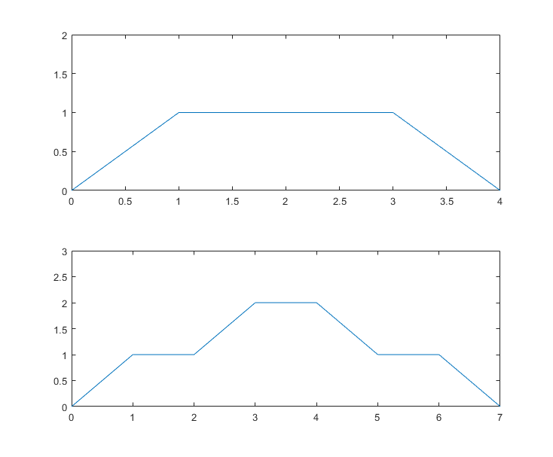

Fig 2.3: Representation of Two Signals

**Conclusion:**

In this experiment we have implemented circular convolution without using built-in function.

We have plotted two signals and also displayed their addition and subtraction.

Lastly, we have represented two given signals in a single figure.